

Blockchain into the Entertainment Market !!

ENTOK PLATFORM

WHITEPAPER

Version 1.0

November 15, 2017

INDEX

1. EXECUTIVE SUMMARY 4

1.1 Biz value 1 : Value for investors 5

1.2 Biz value 2 : Value for Items Market 6

1.3 Biz value 3 : Proposal of the vision for new ecosystem

to entertainment market 6

2. WHY : Cryptocurrency into the entertainment market 6

2.1 Current status and prospect of Hallyu (Korea-born Cultural Wave)

entertainment industry 7

2.2 Change of fund-raising way : ICO (Initial Coin Offering) 7

2.3 Solution for entertainment market with cryptocurrency 8

2.4 Securement of primary base technology 10

3. WHO : Making ENTOK Platform more concrete 11

3.1 Technical development committee 12

3.2 Supervision and management committee 12

3.3 Entertainment Item committee 12

3.4 Public relationship committee 13

3.5 Advisory committee 13

4. WHAT : ENTOK Platform business model 14

4.1 Whole process of ENTOK Platform 14

4.2 Platform process definition & detail 14

4.3 AnyCoin & Sur-Ple Token 15

4.4 Economic and social effects of ENTOK Platform 15

5. HOW : ENTOK Platform technology & management 16

5.1 ENTOK Platform technology 16

5.2 ENTOK Platform integration 18

5.3 ENTOK Platform management 24

6. ICO PROCEDURE : Fund-raising goal & operating plan 27

6.1 ICO subject 27

6.2 ICO target volume 28

6.3 Fund-operating plan 29

7. BOUNTY PROGRAM 31

8. ROADMAP 31

8.1 Roadmap 31

8.2 ICO details plan 32

9. CONCLUSION : Vision statement 34

“Blockchain into the Entertainment Market”

Investment platform for Entertainment based in blockchain

**ENTOK** (Entertainment Token) **Platform**

1. **Executive Summary**

Led by IoT, Social Media Networks, fintech, and blockchain, wind of change in the 4th industrial revolution is blowing fiercely. Especially, all eyes are watching at blockchain technology (armed with the advantage of decentralization, transparency, security, etc.) and cryptocurrency sector; the technology is gradually becoming more stable and wide spread.

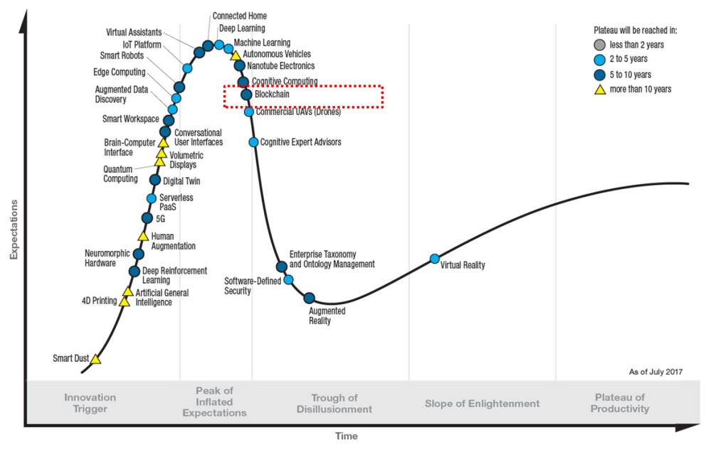

Gartner Hype Cycle for Emerging Technologies, 2017

Entertainment industry is one of the fastest growing segments, just as swift as the development of the technology.

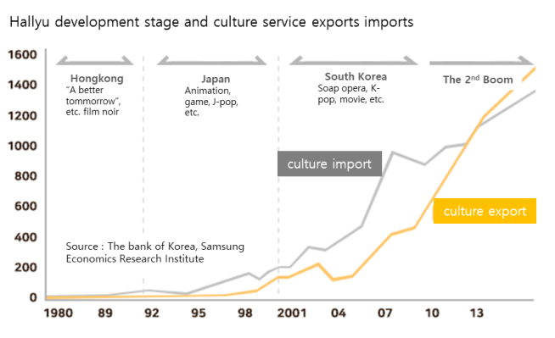

Stages of development in Hallyu culture content and imports and exports figure of cultural service

There is a good outlook for Hallyu entertainment industry which is continuously creating values based on creative ideas. World-famous singer Psy's "Gangnam Style" has played a significant role in reconsidering nation brand as well as creating tremendous economic value. K-Pop which plays a leading role of Hallyu entertainment is no longer just a recreation to listen, watch or enjoy. It has become a solid platform for the world entertainment content market as well as a bridge linking between countries or generations. For instance, EXO, a famous idol group (genuine Korean expression for a pop band), is evaluated the economic value of over 1 trillion KRW in the next decade and similarly, the social and economic value of Hallyu entertainment is expected to be larger than any other. Consumer responses are also changing. The market is increasingly anxious for the talented musicians. Since 2014, the public’s expectations have been high and various broadcast audition programs have demonstrated that the successful applicants have the talents for singing, dancing and composing.

This change in Hallyu entertainment market, especially in idol market, raises K-POP cultural standard and leads global value improvement and global market extension. On the contrary, successful business remains the malformed structure which depends on the ability of large agency. This is also why we need a leading investment model for continuous research and development of high-quality Entertainment Items[1] for the growing global market. ENTOK platform is close to the ideal investment model where technology and culture can be effectively integrated. ENTOK platform enables the investment of the entertainment market, improves the life cycle of Hallyu content and leads the new fandom culture through issuing and trading the first Token based on blockchain for Hallyu entertainment items, which presents a new direction to entertainment industry.

ENTOK platform pursues real value on business as follows:

* 1. Biz-value 1 : value for investors

Funds raised from Investors are used in entertainment business promotion and Token[2] operating. Investors will receive dividends from the revenue generated through the commercialization of items by entertainment agency. Investors can earn profits by selling their token directly on the exchanges.

1.2 Biz-value 2 : value for items market

Token based on blockchain technology ensures transparency throughout its purchasing, distribution and consumption processes. Transparent operation and report of token distribution provide credibility for both investors and buyers. Token issued through ENTOK cannot be falsified and altered, ensuring reliability in the market. Continuous research and development of various entertainment items guarantee scalability into the broader market.

1.3 Biz-value 3 : Proposal of the vision for new ecosystem to entertainment market

ENTOK platform supports continuous development and improvement of high quality Hallyu entertainment contents as well as creation and sale of entertainment exclusive token.

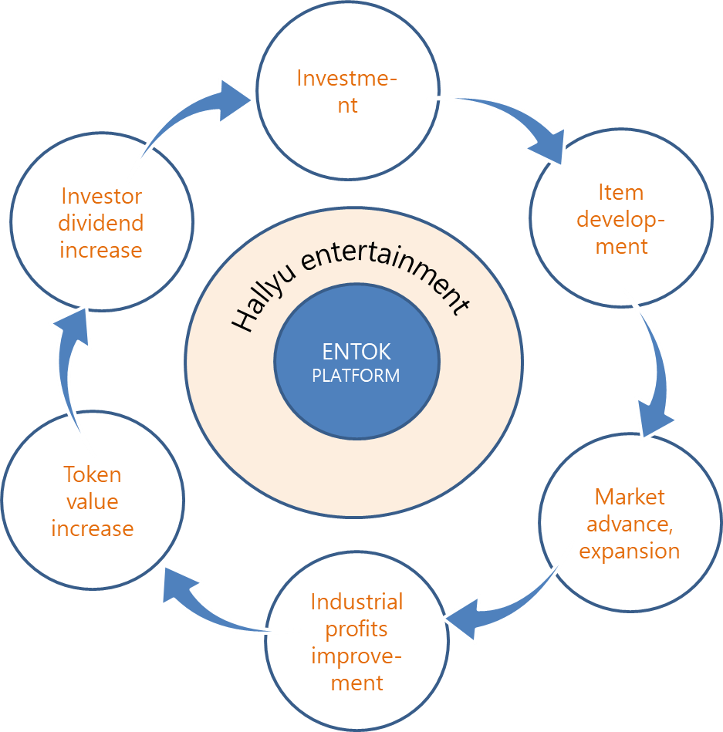

ENTOK Platform ecosystem

Business convergence through ENTOK platform presents a virtuous cycle model of new value investing and content developing across the entertainment business ecosystem. Market conditions in the distribution of Hallyu entertainment items through blockchain-based cryptocurrency have been fully established for Korean and foreign consumers in their 10 ~ 30s who are rapidly acquiring IT technology and are immediately responding to Hallyu content. It is considered as a very attractive investment field.

1. **WHY : Cryptocurrency into the entertainment market**

As a variety of creative businesses are emerging, those are combining their products with IoT environment and utilizing it as a stepping stone to grow. On the other hand, Hallyu entertainment market is built around large entertainment agency, which is not adequately adapted to find and nurture various entertainment items and to enter the market. Things9 aims to consider these issues together and look for solutions through the convergence of technology and culture.

2.1 Current status and prospect of Hallyu entertainment industry

Let's observe the current status of South Korea, which sets regulatory barriers interrupting the development and growth of various entertainment items. Even if an idol group, great item, is formed, it is difficult to commercialize the product except for large agencies due to limitations in infrastructure such as idol group development, fund-raising, operation and marketing. On the other hand, the international situation is acting as a serious variable for large agencies. The economic impact of Chinese retaliation over THAAD and Japan's anti-Korean sentiment has been more than expected. The economic damage of South Korea due to a boycott on Korean product is estimated at 8.5 trillion KRW according to statistics. There is no proper countermeasure to cope with international circumstances and economic issues. Especially, small and medium sized entertainment companies are having difficulty in finding solutions for funds and human resources for globalization. Consequentially, it is inevitable to have investment plans that will continue to search for high-quality entertainment items aimed at global market, which are not limited to specific countries in Hallyu entertainment market.

2.2 Change of fund-raising way : ICO (Initial Coin Offering)

Previously, venture capital has been a wide spread medium of fund-raising. Currently, the development of block chains and cryptocurrency technology is changing trend across business fund-raising. Now it is possible to attract Korean and global investments in a short period of time through the Internet and mobile device. It brings about change not only in the raising method, but also in the size of the investment. The size of investment through ICO has already overtaken that of existing venture capital. Bitcoin is now at the $5,000 mark in 2017 and there has been increasing interest in cryptocurrency around the world. As of September 25th, 2017, the global virtual currency market is worth about $130 billion (approximately 150 trillion KRW).

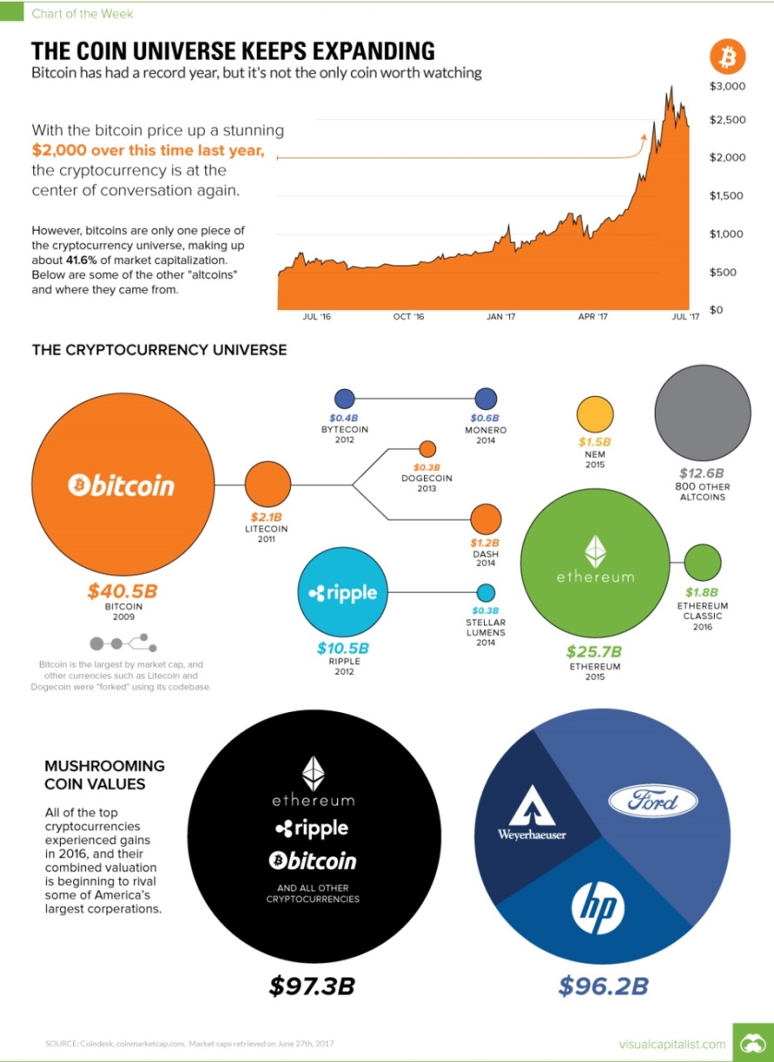

CryptoCurrency Universe *(source: Coindesk, coinmarketcap.com. Market caps retrieved on June 27th, 2017)*

Initially, ICO investments focusing technological aspect of cryptocurrency were the vast majority, but now it continues to be successfully invested in ICO of various technology and service sectors. In the case of 2017, the amount of funds through ICO reached $2.2billion in nine months. We will review the success cases of representative ICO.

|  |  |  |
| --- | --- | --- |
| ICO | Target volume | Feature of platform |
| GNOSIS | $12,000,000 | Combining market prediction with finance |
| CryptoTickets | $23,000,000 | Combining ticket sale with finance |
| KIK | $100,000,000 |  |
| Tezos | $230,000,000 | Cryptocurrency Core Tech |
| ALIS(Japan) | $350,000,000 | Social media for Japanese who do not rely on commercial |
| FileCoin | $260,000,000 | Earning fees in exchange for lending PC capacity |

Success cases of global ICO

Globally, it has been attempting to integrate various business platform developments and services utilizing blockchain and the increase of value cognition is consistently leading to the increase of ICO. As you can see in the Gartner report (2017) mentioned previously, blockchain technology has stepped into the stabilization stage and is universally applied in a diversity of fields. Various policy changes have been detected in South Korea and overseas. As the policy becomes specific and stable, the ICO market will grow rapidly. The key to investment success in ICO is to find a convergence model with other concrete business. Things9 was able to find a solution in Hallyu entertainment market.

* 1. Solution for entertainment market with cryptocurrency

Entertainment producers are attempting the change to the direction of creating brand value across cultural content beyond existing record production planning and management. In order to develop a variety of high-quality entertainment items keeping up with the changes in the management trends, it is necessary to establish an environment and foundation in which investments can flow freely, which is not concentrated in large-scale agencies. Things9 desires to find a solution for Hallyu entertainment market in the latest technology based on blockchain.

**Things9 have sought business ecosystem model which combines entertainment market with reliable cryptocurrency technology.**

The most desirable business ecosystem model that Things9 pursues is a virtuous cycle model of investment, development and growth, which leads to reinvestment.

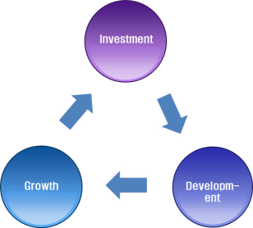

Virtuous cycle business model that Things9 pursues

A lot of resources are needed to find and develop high-quality entertainment items. ICO provides the most effective investment environment for finding and developing entertainment items. The investment funds raised through ICO will be used to develop items and the distribution and sales of the outstanding items will lead to the growth of both entertainment producers and investors. The growth of producers and investors will continue to expand the infrastructure that can lead to reinvestment in the development of entertainment items, consequentially completing the ideal business ecosystem. Things9 assures that ENTOK platform plays a leading role in providing this virtuous cycle model in Korea and abroad. ENTOK platform already secured a sufficiently reliable technology and is able to carry out business immediately through expansion of its associated infrastructure. We are convinced that it will be one of the most successful models that will yield a result in the shortest period of time shortly after ICO.

**The investment of cryptocurrency based on blockchain is the most democratic investment model with the advantage of high potential.**

Cryptocurrency has no government regulators. The circulation, verification, and management of currency can be done autonomously because the cryptocurrency market is steadily growing on the basis of its reliable technology. This is reflected in the fact that the daily trading volume of cryptocurrency market in South Korea is about 2.6 trillion KRW, which is equivalent to that of KOSDAQ market. It does not mean simply that the market is growing but it means that the market is maturing. What is the strength of ICO which makes the market mature? It is based on a solution that supports scalability and rapid transaction in a robust IT infrastructure. ENTOK is the best solution for discovery, production, distribution and consumption of entertainment that investors, entertainment producers and consumers can use when and where it is needed.

* 1. Securement of primary base technology

Things9 has developed all the necessary base solutions for market invigoration and will focus on collaborating with related organizations to raise fund and develop entertainment items through ICO. The following is the base solutions developed by Things9.

**AnyCoin**

Anycoin is a cryptocurrency implemented through ERC-20 Token technology of smart Contract based on Ethereum. It has acquired technology to issue AnyCoin and Sur-Ple Token by applying Ethereum-based ERC-20 Token technology.

**AnyPay**

AnyCoin can be paid with AnyPay (Wallet) in a lot of merchants. Various AltCoins can be used to make payment at the participating merchant using AnyPay. In addition, it is possible to transfer between digital coins through smart contract ERC-20 Token technology.

**AnyPOS**

AnyPos is a payment application for business use that is serviced to member store handling AnyCoin.

**MFCT** (Multi Function Cryptocurrency Trading system)

MFCT is an exchange system under development that enables buy and sell issued Token. MFCT is aiming to provide services that maximize the value of coins by providing a 'transparent and reliable' business model that utilizes blockchain functions.

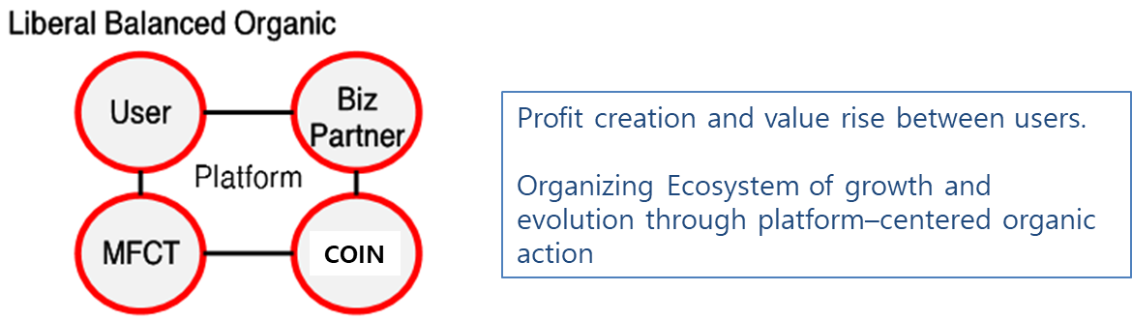

Trading system as an ecosystem that can gain mutual benefit

MFCT is an open system made up of platform operators, users, and Biz partners. The system supports the application of the proven coin and Biz model and the ecosystem can continuously grow and evolve through the organic interaction between the exchange and the coin registrant.

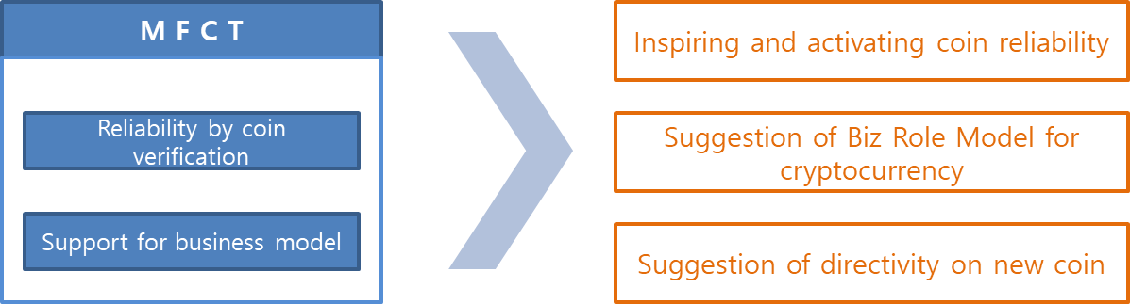

Pursuing value of MFCT

1. **WHO : Making ENTOK Platform more concrete**

ENTOK platform has been completed through cooperation with various expert groups in order to ensure stable investment process in connection with entertainment items.

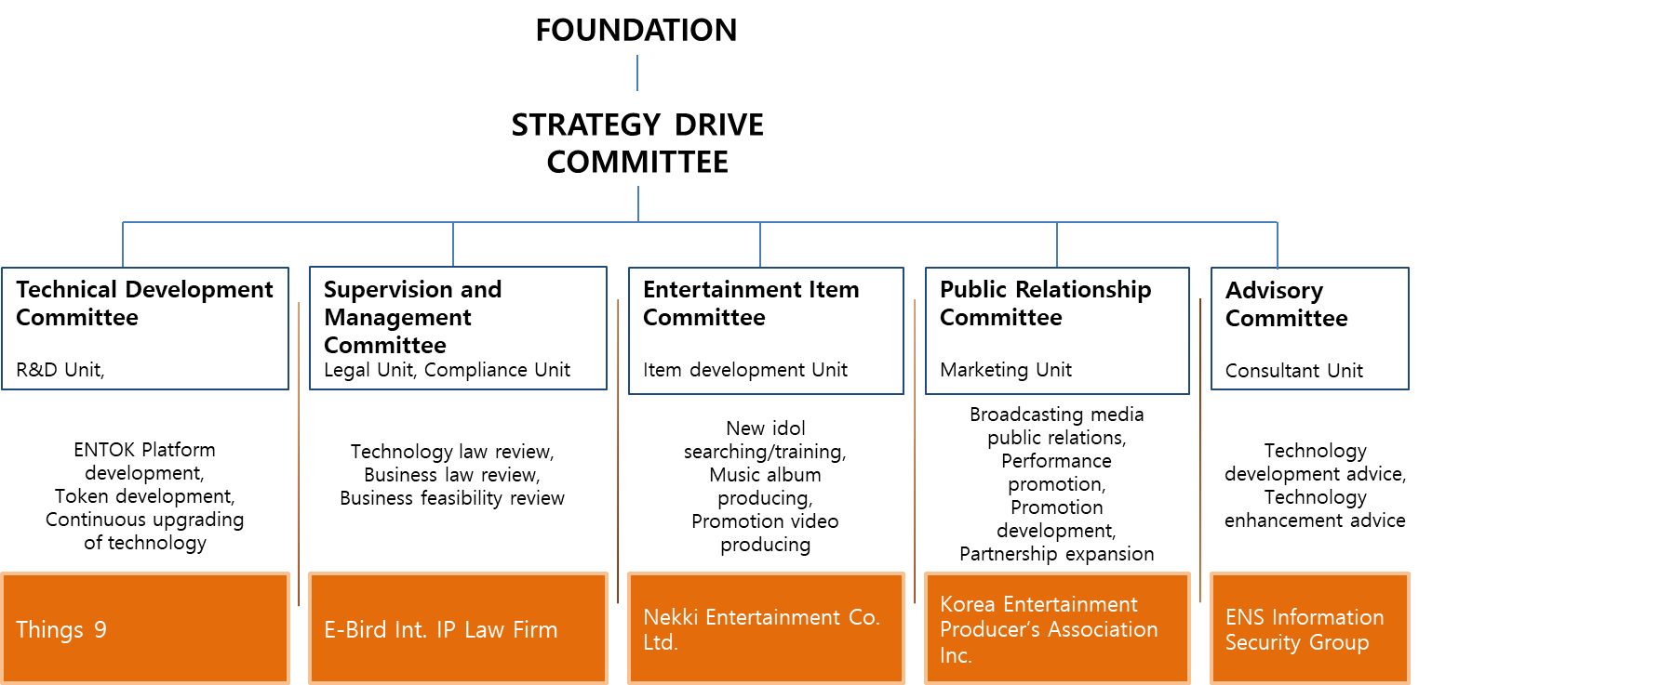

3.1 Technical Development Committee

Things9 develops and continuously upgrades ENTOK platform and encryption token. David Naccache, a professor of École normales supérieure of France and an expert on virtual currency is a technical advisor of the committee.

**Jongbum Im**

Founder & CEO of Things9

Specialist in blockchain and cryptocurrency technology

Development and launch of AnyCoin, AnyPay, AnyPOS

Specializing in convergence of technology and business in various fields

Korea University, MBA

**Hyeseong Yun**

Co-representative & Cofounder of Things9

Ex-ceo of YS Mobile Co., Ltd.

Ex-executive director of YS Consultant Co., Ltd.

**Bonghyeon Seo**

General director of overseas marketing, Things9

General manager of AnyPay service for Japanese market.

General manager of AnyPay service for American market.

3.2 Supervision and Management Committee

It is responsible for the technical and business review of the project. It also reviews the validity throughout the project.

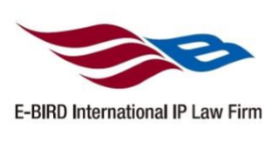**E-Bird International IP Law Firm**.

Specialized agency for technology law in intellectual property right

Domestic and foreign application for patent and utility model registration

Protection of business model, analysis of rights infringement, technology transfer intermediation and technology evaluation

Precedence technical research, corporate intellectual property rights management and strategy establishment, contract writing and review.

* 1. Entertainment Item Committee

It continues to search and train new face entertainment items. It trains the selected item at a high level and produces albums and music videos.

**Nekki Entertainment Co. Ltd.**

Started as A-One Entertainment in 2003 and established as a subsidiary of Nekki Entertainment in 2011

Produced Buzz 1st, 2nd, 3rd album, digital Single album, Buzz Special album, Min Kyung Hoon 1st album and Icon Eyes 1st album

Bongsung Park, CEO of Nekki Entertainment Co., is called the Midas touch of record industry and is striving to find new idol through continuous audition.

* 1. Public Relationship Committee

Through various broadcasting media and on/off-line channels, it promotes public relations and marketing of new entertainment items. It plans the performance of entertainment items and promotion with various media and fans. It will also continue to expand partnership with entertainment organizations.

**Korea Entertainment Producer’s Association Inc.**

Established in 1992, Registered organization of the Ministry of Culture, Sports and Tourism in South Korea.

It consists of 354 members who are leading producers of music and performance and management specialists in the entertainment industry. 2,000 managers and 2,500 artists from member companies are working. As a sponsor of Hallyu Dream concert, it has held large-scale music performances such as Environment concert, Dream concert, and Hallyu Dream concert in order to cultivate the people's cultural life and popular music. It continues to build the infrastructure of popular music industry and promote the rights and interests of member producers.

* 1. Advisory Committee

It is responsible for the advice on technology development and enhancement of ENTOK Platform.

**David Naccache**

Cryptographer and currently a professor at École normale supérieure, France

Ex-professor at Panthéon-Assas University

Ph. D at École nationale supérieure des telecommunications, France

Specialize in Public-key cryptography including the cryptanalysis of digital signature schemes

Design of Naccache-Stern cryptosystem and Naccache-Stern knapsack cryptosystem

1. **WHAT : ENTOK Platform business model**

4.1 Whole process of ENTOK Platform

ENTOK is a transparent and reliable platform which supports investors, entertainment producers and exchanges.

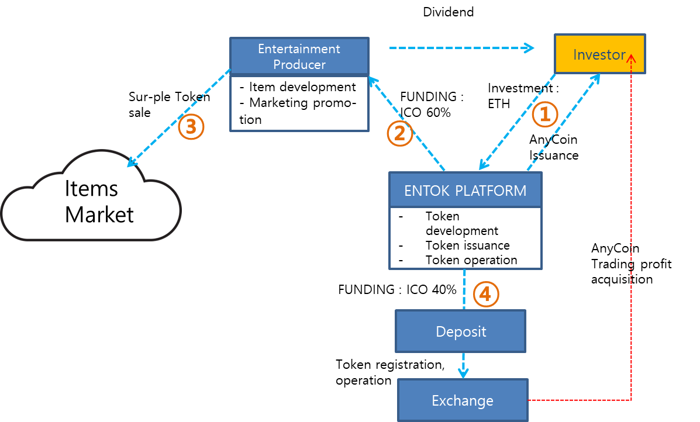

* 1. Platform process definition & detail

1. **The relationship between investor and ENTOK Platform**

The investor deposits Ethereum(ETH) to the ENTOK wallet. ENTOK Platform will pay AnyCoin to the investor in real time when ETH investment is confirmed. AnyCoin is sent to the investor's wallet in proportion to an amount of ETH invested.

1. **The relationship between ENTOK Platform and entertainment production company**

60% of the raised fund will be allocated to an entertainment production company for the development and marketing of entertainment contents. The entertainment company secures funds through the allocated ETH. The company develops and promotes entertainment items with secured funds. The entertainment company will request ENTOK Platform to issue Sur-Ple Token for the developed entertainment items. ENTOK Platform issues Sur-Ple Token and supplies it to the entertainment production company.

1. **The relationship between entertainment production company and Items Market**

Items Market is an on/off-line commerce channel where entertainment products such as merchandising, game, music, movie, promotion video, performance and ticket can be traded.

While Things9 creates and operates a social Item Marketplace platform, entertainment production company supplies and sells Sur-Ple Token to Items Market. Sur-Ple Token supplied to Items Market are used to purchase entertainment items.

1. **The relationship between ENTOK Platform and exchange**

Shortly after the end of ICO, 40% of the raised fund will be allocated to the deposit. AnyCoin equivalent to the amount of deposit will be issued. The issued AnyCoin will be registered on an exchange. AnyCoins registered on the exchange can be traded by regular investors and ICO investors on the exchange. The price of AnyCoin is adjusted through the exchange (market).

* 1. AnyCoin & Sur-Ple Token

Two types of token, AnyCoin and Sur-Ple Token, are issued and operated in ENTOK platform business.

**AnyCoin**

AnyCoin is issued through ENTOK Platform. AnyCoin has to be issued as a single token. AnyCoin is distributed to the investor in real time. Once AnyCoin lists on the exchange after the end of ICO, the investor who holds AnyCoin can trade on the exchange. 40% of the investment allocated to a deposit will be issued with AnyCoin and registered on the exchange. AnyCoins registered on the Exchange can be traded only on the exchange by investors and individuals. The value of the AnyCoin is changed by the trading market. AnyCoin can be purchased with other Coins.

**Sur-Ple Token**

Sur-Ple Token begins to be issued at the request of the entertainment production company. Sur-Ple Token is sold and supplied to Items Market through an entertainment production company. Multiple tokens can be issued per item. Sur-Ple Token is a fixed value product and is not affected by the market. Sur-Ple Token cannot be traded between individuals.

* 1. Economic and social effects of ENTOK Platform

**Social effects**

Because blockchain technology is applied to Sur-Ple Token issued by ENTOK, the issuance is transparent and the transaction record can be verified in all processes of distribution and consumption and consequentially, it keeps the consumer’s risk at minimum. The transaction ledger based on blockchain technology enables transparent and reliable transactions between entertainment agencies and partners. Because of these characteristics, the dividend information based on profit generated by the project is open transparently to the investors, ensuring the continued reliability between investors and entertainment producers.

**Economic effects**

Frauds are frequently occurring in off-line and online transactions because existing paper gift cards and new-type gift cards (mobile gift cards, mobile coupons, etc.) are easy to forge and falsify.

As of 2016, gift card market of South Korea is estimated to reach 11.3 trillion KRW. The issuance of paper gift cards is estimated to be worth more than 9.6 trillion KRW according to the data from Korea Minting and Security Printing Corporation and the estimated value of new-type gift cards is expected to exceed 1.7 trillion KRW according to the survey from National Assembly Research Service. Smart contract ERC-20 Sur-Ple Token based on blockchain has an unlimited potential as an effective alternative to existing paper gift cards and new-type gift cards by enhancing security, transparency and reliability. Also, in the case of paper gift cards, it takes a lot of cost and time to issue, distribute and collect. With Sur-Ple Token, this cost is close to zero. Through high-performance system and Internet infrastructure, the whole process of issuing and distributing can be done instantly. In the case of existing paper gift cards and new-type gift cards, it is no small burden on traders due to high commissions. Sur-Ple Token is providing a lot of profits for traders through its low commission policy.

**5. HOW : ENTOK Platform Technology & Management**

5.1 ENTOK Platform Technology

**ERC-20 Token of smart contract based on Ethereum**

ERC-20 (Ethereum Request for Comments) is a standard for ensuring the compatibility between tokens developed on Ethereum network (blockchain). The ERC-20 must support the attributes of smart contract, and ERC-20 compliant tokens can be held in a standard Ethereum wallet (MyEtherWallet, MetaMask, Mist, etc.). This standard creates many advantages such as simplification of digital currency exchange and ultimately facilitates the development of cryptocurrency tokens. ERC-20 defines the principal functions of cryptocurrency including the method of token transfer, the method of token information request and the format of events that occur to the token. These are defined in ERC-20 by several methods. An example of methods is as follows:

function transfer(address _to, uint256 _value) returns (bool success)

'_value' is sent to 'address_to' through the transfer method. The result is either success or failure and is returned as a boolean. ERC-20 provides a standard for easily implementing functions that a single currency requires through these methods. By following the ERC-20 standard, new smart token can be created easily. Many recent Ethereum-based coins were mostly created with these conveniences. By using it along with smart contract of the Ethereum network, the process of creating new digital currency is dramatically accelerated. The transaction of digital currency issued through blockchain has main functions different from those of existing currency as follows:

- Transparency : Anyone participating in the transaction can track the transfer record between accounts.

- Immutability : Once a transaction is approved, it cannot be canceled and no one can interfere.

- Transcendence : Token can be transferred easily to any country in the world without restriction of space.

- Immediacy : Transfer is implemented almost immediately and can be confirmed within minutes.

**Patented digital currency transaction system, AnyPay** (application no. 10-2017-0096905)

System and method for digital currency transaction

This patent is about the transaction method of digital currency. It describes that digital currency holder is able to directly exchange for commodity money. Also, any error that may occur during blockchain generation can be prevented and security for transactional information can be improved. According to the embodiment of this patent, digital currency transaction process can be simplified by directly exchanging for commodity money through an exchange server. And security for transactional record can be enhanced by using a virtual POS address. Also, it can raise interests in cryptocurrency by adopting the game of cryptocurrency mining. In addition, it is possible to prevent an error that may occur in the blockchain generation process and to enhance the security for transaction details of the digital currency by changing the digital currency information based on the transaction data whose validity has been verified

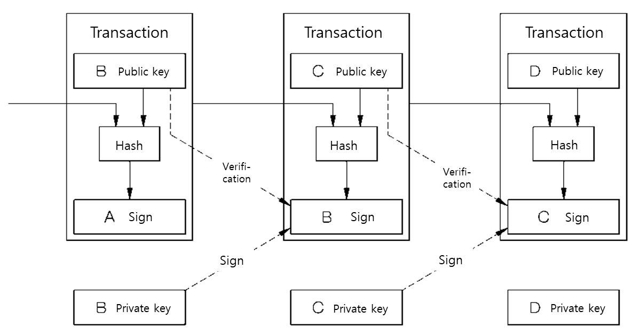

Transaction structure of cryptocurrency on blockchain

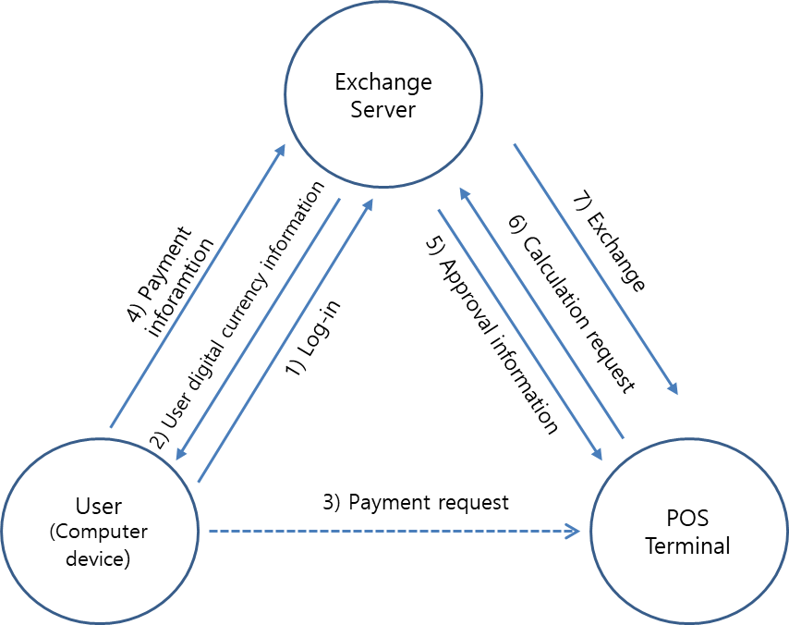

Flowchart of cryptocurrency transaction system

5.2 ENTOK Platform integration

ENTOK Platform completes the ultimate advanced ecosystem model in four steps as follows: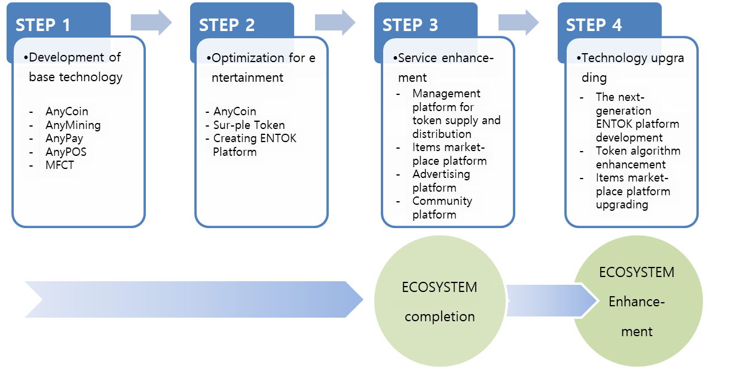

1. **STEP1 : Development of base technology**

It is the stage to develop technologies and solutions that are the base of ENTOK Platform. AnyCoin was developed with the technology of Ethereum smart contract ERC-20 Token. The technical standards of ERC-20 are as follows.









For consumers to use AnyCoin applied with ERC-20 Standard, two platforms (AnyPay for paying and AnyPOS for receiving the payment) are required.



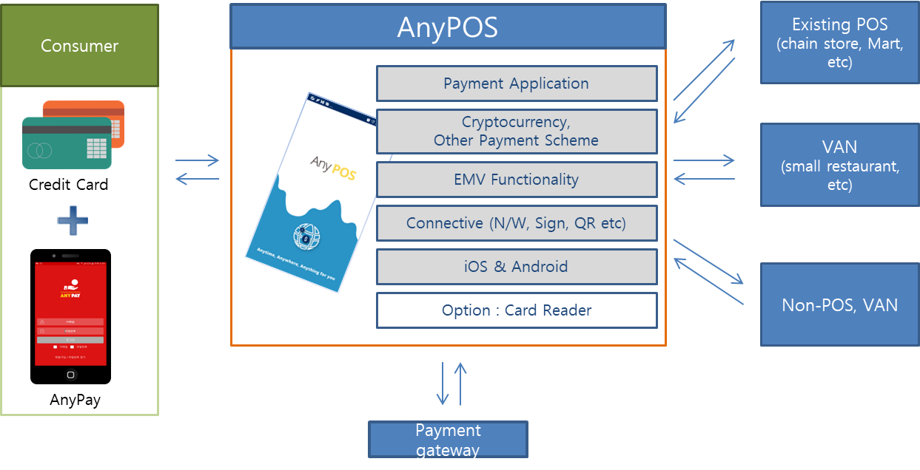

Service relation with offline retail store through AnyPay and AnyPOS

**AnyMining**

It is an application that allows anyone to easily mine AnyCoin through game. This AR (Augmented Reality) game allows collecting coins and using them like cash.

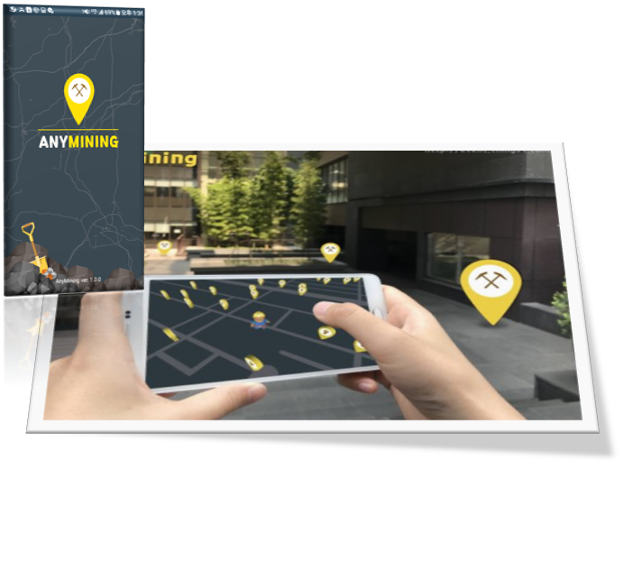AnyCoin mining through AnyMining app.

We are also developing a solution for investment and integrated management of virtual currency, which can secure the liquidity of transaction between virtual currency and commodity.

|  |
| --- |
| MFCT (Multi Function Cryptocurrency Trading System) |
| MFCT system allows cryptocurrency to be raised in initial offering and allows the ICO token that is paid in exchange for the investment to be used for actual trading. It is an integrated system of investment and management using virtual currency that can secure the liquidity of virtual currency and cash transactions. The MFCT system includes a step of accepting ICO request from a terminal of the company which wants ICO, a step of collecting virtual currency investor in cooperation with the plurality of investor terminals based on the information of the ICO company, a step of providing ICO tokens corresponding to the investment amount to the investor’s terminal as a result of collecting the virtual currency investor, and a step of distributing the profit to the investor according to the result of the ICO company. Things9 has finished an application for patents for its technology. (* Patent application number : 10-2017-0144456) |

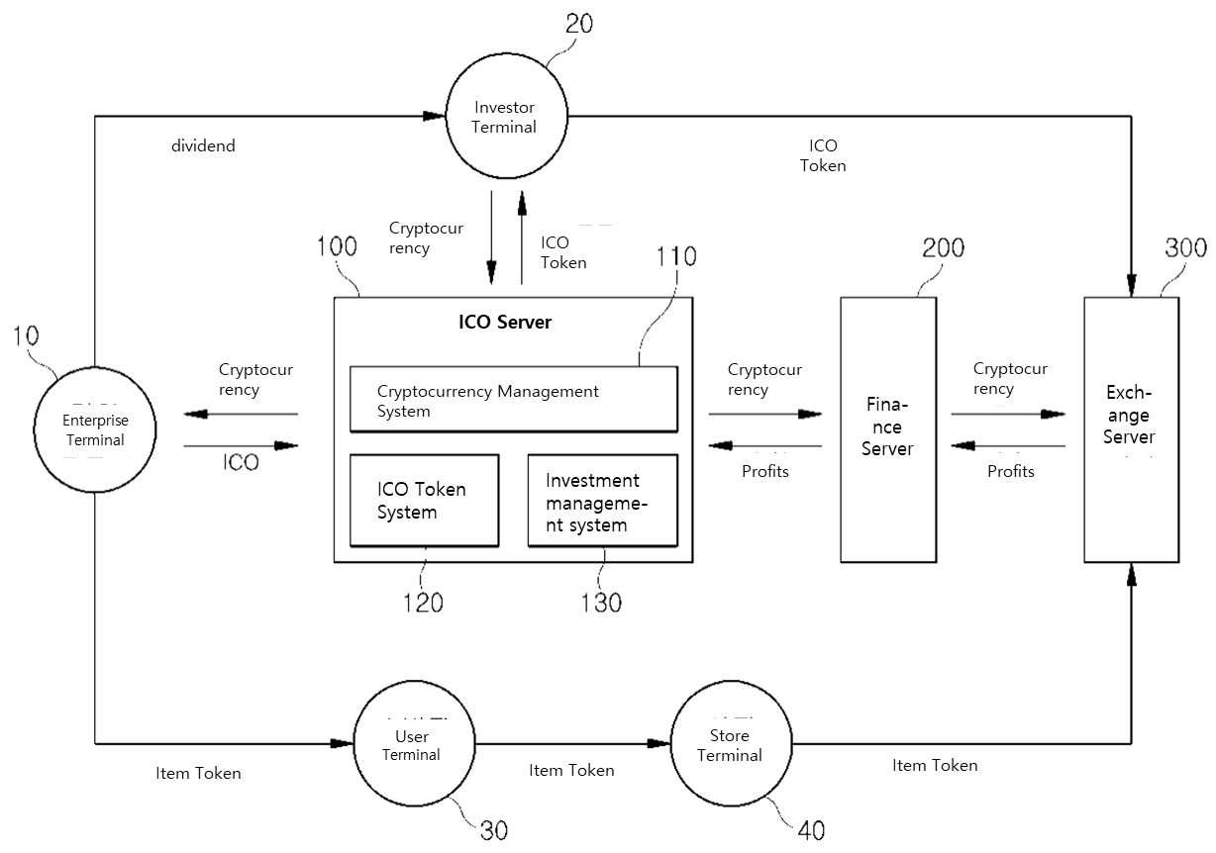

MFCT system diagram

1. **STEP 2 : Optimization for entertainment**

A platform is established to connect the base technology built in STEP 1 with the entertainment market. At this stage, we advance the issuance of Sur-Ple Token for entertainment through the technology of AnyCoin.

|  |
| --- |
| AnyCoin |
| It is a cryptocurrency developed and issued based on Ethereum smart contract ERC-20 technology. AnyCoin is registered and operated not only in MFCT(Multi Function Cryptocurrency Trading system) but also in global cryptocurrency exchanges. AnyCoin can also be exchanged with other cryptocurrency through exchanges. |
| Sur-Ple Token |
| It is a functional cryptocurrency developed and issued based on Ethereum smart contract ERC-20 technology. Sur-Ple Token can be developed and issued for each entertainment item. When Sur-Ple Token is issued, the information of issuer and distributor (partner company) is generated and transparent transaction is guaranteed. Sur-Ple Token is a fixed value token with a fixed price. Sur-Ple Token can be extended to various markets through ENTOK Platform. |
| ENTOK Platform |
| ENTOK platform performs the following functions. -Investment management -Token issuance and transaction management -Token listing and operating on exchange -Token cross-border listing and operating on global exchange |

1. **STEP 3 : Service enhancement**

A management platform is established to facilitate the supply and distribution of token. We also develop Social item marketplace platform to ensure easy accessibility for a wide range of consumers.

|  |
| --- |
| Management system creating Token supply and distribution |
| We develop a management module for token development request and token development sales table and provide to entertainment item production company. Also we develop a management module for token purchase and trade cost and provide to entertainment distribution partner company. This will allow token's market distribution process to be conducted and managed quickly. The integrated management module for supply and distribution is embedded and operated in ENTOK platform. |
| Social items marketplace platform creating |
| We develop template and API and build the market-connected platform to create a marketplace where consumers can purchase various entertainment items token. Various on/off-line contents are sold and distributed by infrastructure including user through this platform. - Developing item registration template : registration and transaction of various items on marketplace  - Developing item selling module : market expansion related with on/off-line sales network and social network market through providing API |
| Advertising platform creating |
| We create a platform for advertisements and events on the Social items marketplace. We promote the service expansion through sharing with platform, and build the optimal system using Things9's Witty solution. * Witty  Witty is an app that automatically guides services through Beacon to customer who is visiting to offline stores. The customer's smartphone senses Beacon's BLE signal from the device installed at the store when visiting the store. Witty receives the current store information from the server and provides the information including available service, advertisement and event to customers. Through this, various event promotions can be performed and advertisement event using the advertisement module in the mobile platform can be performed. |
| Community platform creating |
| AnyTalk which Things9 developed is a mobile instant messenger app that is automatically translated into over 100 languages. When AR interpreter character interprets, users may enjoy the entertaining value of the service just as the user is sending her message. It also runs a variety of entertainment information communities to provide a space where entertainment idol and fans can interact. |

We provide convergent services which social items marketplace platform, advertising platform and community platform are interconnected.

1. **STEP 4 : Technology upgrading**

It is the stage to upgrade to the next-generation ENTOK platform. In order to integrate with various items, we enhance the algorithm of token and upgrade the function and security of platform. The main goals of upgrading are as follows:

|  |
| --- |
| Token algorithm enhancement |
| - Security improvement - Block generation, verification performance improvement |
| Next-generation ENTOK platform development |
| - O2O service-connected platform expansion - ERP solution-connected platform expansion - Entertainment business contract platform expansion |
| Service platform upgrading |
| - Social items marketplace platform upgrading  Web & mobile UI/UX improvement  Mobile platform enhancement - Advertising platform upgrading - Community platform upgrading |

5.3 ENTOK Platform Management

**Token operation**

AnyCoin can be bought and sold on the exchange.

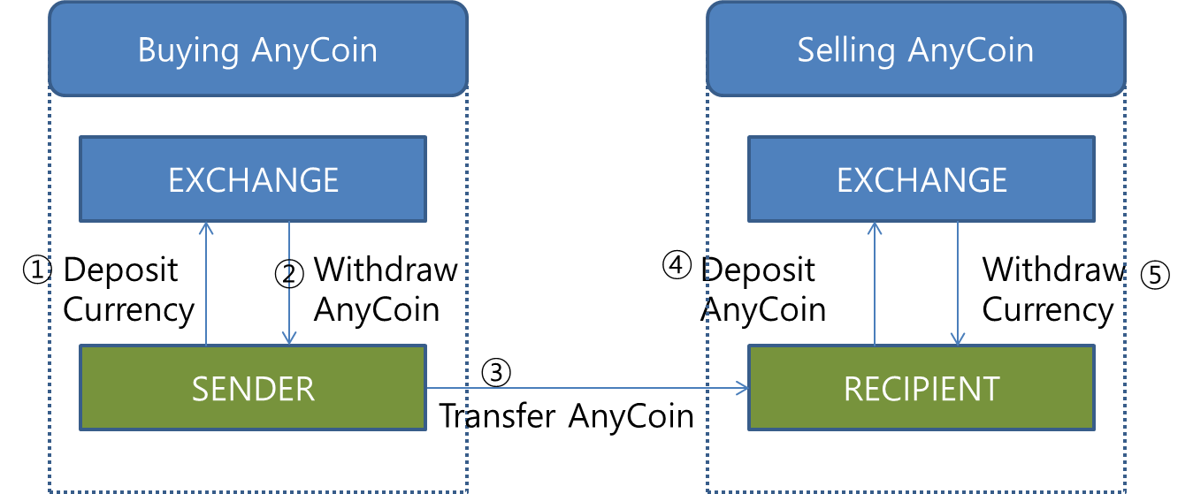

AnyCoin sales process

Sur-Ple Token is a fixed value token that is supplied to Items Market through the entertainment production company and can be issued in multiple Token corresponding to various entertainment items. Sur-Ple Token is supplied directly to Items Market through the entertainment production company without going through the exchange.

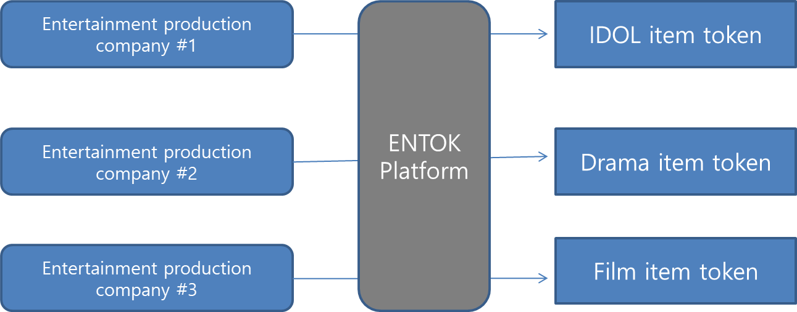

Multiple items token operation

**Marketing operation**

There are various marketing plans which idol group “Sur-Ple” collaborates with several entertainment channels through ENTOK platform. Major marketing promotion plans are as follows.

1. **Involving the best singers of South Korea in featuring**

Involving the best singers of South Korea in featuring will attract public attention to entertainment item (Idol) and will promote brand value. At present, we are in discussions with A-Pink, EXID, Ailee and others.

1. **Appearance in broadcast program that can show skill**

It is possible to appear in several programs that can show idol’s skill and it is planned to appear more than 20 times in music broadcast programs. Also it is planned to proceed with media marketing that can be contained in real-time search word list of various portals.

1. **Utilization of MCN(Internet personal broadcasting) media**

It is planned to broadcast online busking differentiated from offline busking which has many constraints such as place, time, personnel and climate. We will concentrate on proving ability and acquiring familiarity through interactive communication such as song request accepting and immediate composing.

1. **Appearance in entertainment show**

It will raise the familiarity and awareness through the appearance of famous entertainment show. It will appear in the form of a group of three “Sur-Ple” members in the MBC entertainment show "I live alone" and show their work environment and unique perspective, which will appeal to younger generation. Also it will participate in a song festival of MBC entertainment show “Infinite Challenge”. This show has ever made the new singers famous and Sur-Ple will appear to show its composing skill and musical talent. It will appear in the SBS entertainment show “Jungle's Law”. It is an entertainment program whose format is the survival in the wild. It is able to make the audience feel friendly through various artistic characters such as masculine beauty through hunting and healthy body or unexpected ingenuous beauty revealed during unfamiliar wild adventure.

1. **Avoid one-time fan service and aim at continuous high-quality music broadcasting**

We will continue to communicate with generations familiar with internet broadcasting including Africa TV, YouTube, etc. We will provide high-quality music broadcasting like mini concert as well as one-time fan service such as Naver V app.

1. **Collaboration with various existing platforms**

We will collaborate with existing platforms built stably such as overseas Twitch TV as well as Korean media platforms such as YouTube, Cacao TV and Naver V app.

1. **Utilization of mobile infrastructure**

Unlike offline bus king which has various limitations such as time, space and climate, we will continue to develop various promotions that can be accessed only by smart phones and thereby secure a wide range of overseas users.

**Extended operation of market**

At the time of ICO promotion, we develop and sell Sur-Ple Token for entertainment item (Idol group). The range of entertainment items is infinitely expandable. After the development of the idol group, we invest in the search and development of various entertainment items below. The categories of items will gradually expand.

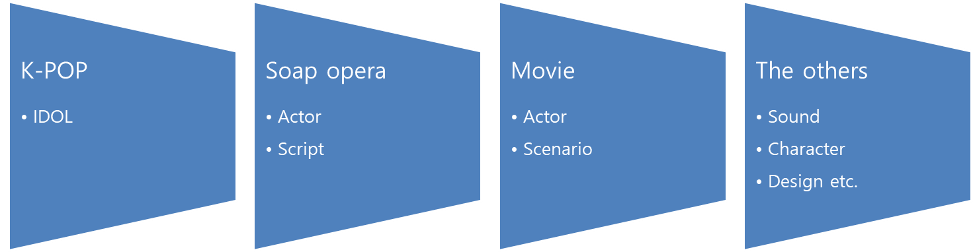

**ICO results Report and publication**

The successful ICO results and the business status are transparently disclosed through reputable organization and press media.

|  |
| --- |
| - Released by global ICO report website  Token Report : http://tokenreport.com |
| - Released by official website  www.sur-ple-ico.com  www.things9.com |
| - Released by SNS  Facebook  Instagram, LinkedIn |
| - Released by Magazine  ICO world |

The publication schedule will follow the Business Roadmap.

**6. ICO Procedure : Fund-raising goal and operating plan**

6.1 ICO subject

**The boy trio idol band Sur-Ple**

Idol group Sur-Ple is a band made up of three boys born in 1996~1997.

|  |  |  |  |
| --- | --- | --- | --- |
| Member | Profile | Position | Specialty |
| Cha Bum-Jin | -Birth : Apr.1996 (born in Seoul) -Body : 178 Cm / 56 Kg | Bass | Playing the bass and guitar, Songwriting skill |
| Young-Kong | -Birth : Feb.1996 (born in Seoul) -Body : 177 Cm / 55Kg | Guitar & songwriting | Professional guitar skill,  Playing the keyboards, Composing skill |
| Hyeyum | -Birth : Jul.1997 (born in Seoul) -Body : 179 Cm / 65 Kg | Vocal | Writing and composing skill, Playing the guitar, Majored in piano |

- Juniors at the age of 20-21

It is made up of young members who have rooms to grow. They already have the ability to write and compose based on unlimited potential and they will be able to demonstrate their superiority through experience, effort and training.

- Singer-songwriter with the strength of writing and composing

Each member’s ability to play the different instruments and compose the songs creates a synergy effect and it is making high-quality songs based on this synergy.

- Requests for songs from famous singers

Sur-Ple is already well known for its songwriting talent in the entertainment market and is receiving requests for songs from famous singers such as A-Pink, Ailee, and EXID.

- Good looks

It also has a star quality based on the appearance as well as the popularity of songs.

The Idol group Sur-Ple is equipped with elements that can satisfy the needs of various fan bases including its ability to write and compose songs, excellent performance, great singing ability and good looks. Sur-Ple is currently making four songs from Part 1 to Part 4 and in the middle of 2018, it will release an album with eight songs totally, which is four songs from Part 1 to Part 4 and four new songs more.

6.2 Target volume of ICO

ICO will be conducted for the development and successful market release of the first entertainment item, Idol Group 'Sur-Ple', and plan to raise Ethereum equivalent of 15 billion KRW.

- ICO Plan

ICO promotion time : before the debut of Idol group ‘Sur-Ple’

ICO goal : the development of content and marketing

Fund-raising term : November, 15th, 2017. ~ December, 5th, 2017.

Target volume for tokens sale : 43,000 ETH (approximately 15 billion KRW)

Maximum number of generated tokens : 30,100,000 ANYCOIN (refer to*, 1ANYCOIN = 0.0014ETH)

- Listing on exchange ; We plans to place tokens on exchanges within a month after the completion of ICO.

After the completion of ICO, ENTOK Platform business is implemented immediately and tokens based on Ethereum smart contract ERC-20 are issued. Specific methods and guidelines for participating in ICO will be announced prior to ICO start. Once investors participating in the development and support of ENTOK Platform Business send Ethereum to designated Ethereum address, Tokens are distributed to ICO investors at a rate of 700 AnyCoin per 1 ETH in real-time. AnyCoin is issued as soon as ETH deposit is confirmed during the ICO. AnyCoin received by investor can be traded on the exchange where it is listed after the completion of ICO.

* 1. Fund-operating plan

The target volume of ICO is 43,000 ETH equivalent to 15 billion KRW, of which 60% is used for content development and marketing and 40% is used for the operation of exchange.

**Content development & marketing : 60% of ICO funds (25,800 ETH)**

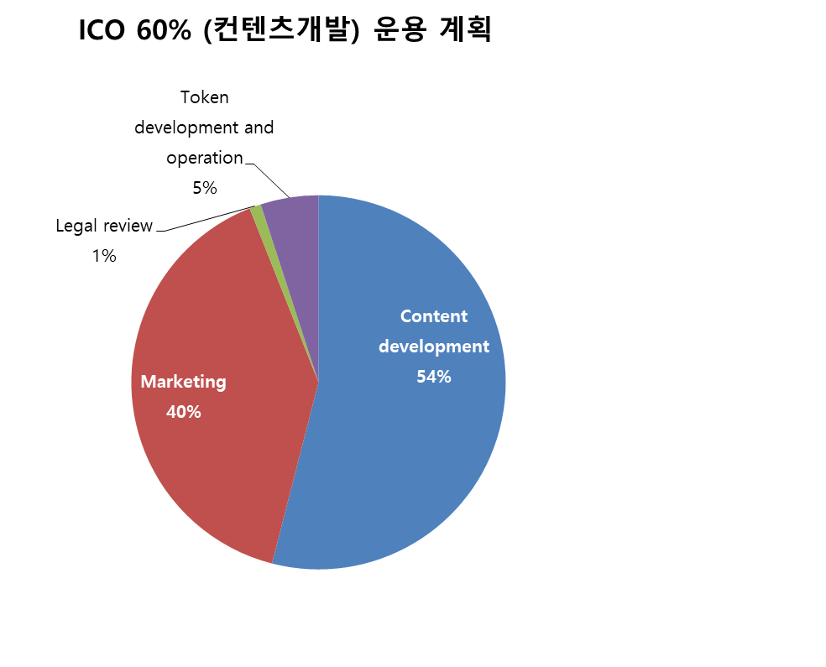

Sixty percent of ICO funds are a content development budget and fifty-four percent of that budget is used to produce high-quality idol groups through the search and development of Hallyu entertainment item (idol). We will proceed with the following activities to produce outstanding idol groups.

-Idol training

-Album producing (featuring, on-line studio, cover photograph)

-promotion video

Forty percent of the content development budget is used for various activities and strategic marketing of idol group.

-Twice-yearly promotion for an idol(refer to roadmap)

-Rapid publicity through social network and multilateral media marketing

-Broadcasting activity (supported of costume, stylist, activity expense, vehicle, bodyguard, etc.)

-다양한 언론매체 홍보 진행

One percent of the content development budget is used for business legal review by a professional legal advisory committee.

Five percent of the content development budget is used for development and operation of Token. It is the cost of token issuance and transaction process management. It includes the operation of server, database system, storage, security solution and security network that make up the exchange. The issued Token is registered for the trading and both WEB and mobile interface for Token trading are provided. This budget includes the cost of development manpower operation and development system operation.

**Exchange fund(deposit) operation : 40% of ICO funds (17,200 ETH)**

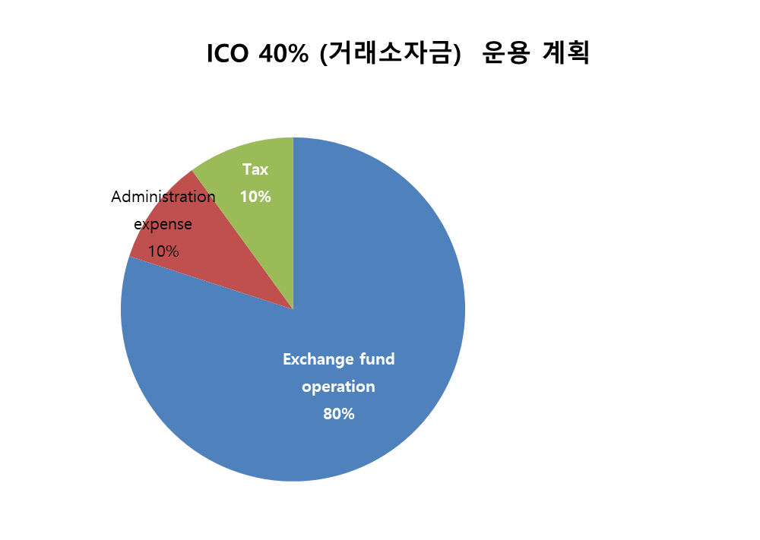

Forty percent of ICO funds (hereinafter referred to as "exchange fund") will be allocated to a deposit and used for the exchange operation including Token issuance. Eighty percent of this exchange fund is issued in Tokens and those are registered in the exchange. Registered tokens can be traded between investors and individuals. Ten percent of the exchange fund is used for the administrative expense of this business. Each allotment of ICO funds raised includes 10% tax.

**7. Bounty program**

Investors receive AnyCoin by the following rate.

**AnyCoin rate**

-Price of AnyCoin is “1 ETH = 700 AnyCoin”

Investors will be paid dividends based on revenue from the entertainment company's item (Idol). The dividend implementation schedule is specified in roadmap and the size of dividend will be

informed at a later announcement. Investors can sell their own AnyCoins directly on exchanges and will be able to make profits.

**8. Roadmap : business details plan and schedule**

* 1. Roadmap

|  |  |
| --- | --- |
| Year | Activities |
| 2015 | O2O platform developing  O2O platform-based social utilities app, Witty, launching  - Applyingin twelve branches of six brands including Pascucci  - Applying in six brands including Glass Story. Ltd |
| 2016 | Have:ON ECO system  -> Enterprise Biz platform, O2O platform-linked system developing  Enterprise Biz platform-based cryptocurrency exchange, Soulbitcoin, building  O2O platform-based parking sharing service, PISS, launching |
| 2017 | Enterprise Biz platform-based AnyPOS, AnyPay building  Have:ON ECO System + AR technology-based SoulTalk building  Have:ON ECO System-based parking sharing service, PISS v2.0 launching  Enterprise Biz platform-based Have:ON ERP for medium and small business  AnyPay Experiences  -AnyCoin, AnyMining launching  -AnyCoin Japan launching  -AnyCoin pre-sale |
| Nov. 2017 | ICO  Real-time AnyCoin distribution for investor  Idol group ‘Sur-Ple’ 1st recording release  The 1st marketing promotion |
| Dec. 2017 | Idol group ‘Sur-Ple’ 2nd recording release  The 2nd marketing promotion  Sur-Ple Token issuance  ICO result report  Exchange listing of AnyCoin |
| 2018 Q1~Q2 | Various marketing promotion & regular promotion  Idol group TV and cable channel appearance and global partnership promotion |
| 2018 Q3~Q4 | Idol group partnership expansion abroad, overseas expansion  ENTOK Management Platform building  ENTOK Social Market Platform building  Year-end settlement of 2018 |
| 2019 | Provision of dividends in February (in the case of profits)  ENTOK version update  -technology/security update  -Service update |

* 1. ICO details plan

Album production and activities for idol group will be implemented in earnest through ICO.

- Nov. 2017 : ICO & Idol group 1st recording release

ICO will be promoted for 3 weeks on 15 November to 5 December and IDOL Group 'Sur-Ple' 1st recording will be released using the funds raised. In case of broadcasting review, the release schedule may be slightly changed. The female IDOL group EXID participates in featuring. Also included is a duet with the singer Jo Dukbae on the 1st recording. Utilizing the star power Jo enjoys in Korean music scene, Sur-Ple expects its recognition to grow larger, which in turn will yield effective and positive marketing strategy. Through collaboration with Group EXID and Jo Dukbae, it aims to acquire the reputation and awareness which attracts viewers of all ages. The 1st announcement of the recording is reported through about 40 media including the biggest newspaper in Korean. Then, it introduces the recording through Korea’s largest digital music distribution and community platform including but not limited to Bugs, Melon, M-net. At the same time, we will collaborate with major Korean internet search engines such as Naver and Daum.

- Dec. 2017 : Idol group 2nd recording release and Exchange listing of AnyCoin

We promote Idol Group Sur-Ple's online busking. The show will be broadcasted online for one hour from 6:00 pm to 7:00 pm every Monday and Thursday evening. Online busking will be based on a platform capable of live broadcast such as Sur-Ple’s official website, YouTube and Facebook. Sur-Ple's 2nd recording source is ready for broadcast regulation. In the 2nd sound source, EXID or Ailee will participate in featuring. We will also promote the collaboration with portals following online busking. Currently, there are discussions with official channels of each internet portals such as Naver V app. Sur-Ple's item token will be issued and distributed through Items Market and AnyCoin will be listed on the exchange by the end of December 2017. At the completion of the listing, the IDOL Group's activities will be on track and the value of the AnyCoin will rise.

- 2018 Q1 ~ Q2 : Various marketing promotion and Idol group 3rd recording release

Full-scale promotion will be carried out. The mini album will be released at the end of January. At the same time, it will appear on TV and cable channels until the end of March. KBS Music Bank, MBC Music Center, SBS Popular Song, KBS Yu Hee-yeol’s Sketchbook are among the music shows that Sur-Ple schedules to appear. By appearing on a broadcast program, it will raise public awareness. Sur-Ple is planning to enter overseas market after Korean Broadcasting Program. Attempts to enter Japanese market will be arranged with the help of Johnny’s Production which controls Universal Records, Power Records, and some of the most famous Japanese artists. We will cooperate with China Star, the largest management company of China and Southeast Asia, on local broadcasting and management cooperation related to overseas value-added contents such as concerts, performances and events. In the second half of June, we will announce the 3rd recording.

- 2018 Q3 ~ Q4 : Idol group 1st album release

On July 18th, Sur-Ple's first album will be released. This album contains 8 songs. From this point on, we will start overseas activities in earnest. It focuses on performing and broadcasting activities in Japan and China. We will develop a social market platform to expand the market of Sur-Ple Token in accordance with Sur-Ple's activities and awareness. We will be able to sell and distribute Sur-Ple Tokens in connection with various social platforms. In addition, a management platform for transparent management of the issue, supply and distribution of Sur-Ple Tokens is also established. Through this, it is possible to efficiently manage the whole process from item development to distribution of entertainment production companies and partner companies.

- 2019

A wide range of markets are created around the world with the increase of idol group's activities in Korea and abroad and we will continue to upgrade ENTOK platform to support them. We improve system security factors, system technology factors and blockchain algorithms for the stable operation of platform. At the same time, we will upgrade the hardware that runs ENTOK platform. Major hardware upgrade will take place in 2019, while minor ones are constantly ongoing even now. ENTOK platform will be upgraded to a system that can inter-operate with a variety of on/off-line markets and absorb a broad range of Hallyu content consumers in Korea and overseas.

**9. Conclusion : Vision Statement**

The goal of ENTOK platform is to provide a converged business platform that can be operated on the basis of contents created in entertainment market and investments in cryptocurrency based on blockchain. ENTOK will be recognized as a next-generation investment platform that drives change in the entertainment market including idol, TV series, movie and character markets. ENTOK aims to accomplish these goals by taking advantage of the transparency, reliability, security and integrity that can be achieved through blockchain technology. AnyCoin issued through ENTOK platform completes the virtuous circle of value creation, investor's profit from value rise and reinvestment. The Sur-Ple Token issued through the ENTOK platform gives consumers the opportunity to participate in the discovery and development of high-quality entertainment content. In conclusion, ENTOK platform will be the most effective model that can narrow the gap between investors, consumers and entertainment item industries and create more reliable investment culture.

1. Entertainment Items : Singers, actors, soap opera and movies are called Entertainment Items in this project.
2. Token : AnyCoin for investor and exchange, and Sur-Ple Token for transaction between entertainment company and partner marketing agency are issued in this project.